JavaScript Operators
Operators are for Mathematical and Logical Computations
- The Assignment Operator = assigns values
- The Addition Operator + adds values
- The Multiplication Operator * multiplies values
- The Comparison Operator > compares values
JavaScript Assignment
The Assignment Operator (=) assigns a value to a variable:
let x = 10;
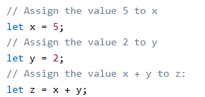
JavaScript Addition
The Addition Operator (+) adds numbers:
Adding

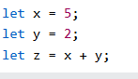
JavaScript Multiplication :
The Multiplication Operator (*) multiplies numbers:
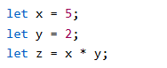

Types of JavaScript Operators
There are different types of JavaScript operators:
- Arithmetic Operators
- Assignment Operators
- Comparison Operators
- Logical Operators

Arithmetic Operators

